LOCAL GOVERNMENT ACT 1972

PARISH OF TANGMERE
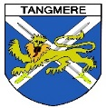

ANNUAL MEETING OF ELECTORS

NOTICE IS HEREBY GIVEN THAT-
The Annual Meeting of Electors for the Parish of Tangmere
will be held at
Tangmere Village Centre, Malcolm Road Tangmere PO20 2HS
On Thursday 28 March 2024 at 7pm.

Local Government Electors for the Parish will be entitled to speak and vote at the Meeting which will be open to the public.

The business to be transacted at the Meeting will be as follows:-

- Minutes of the Annual Meeting of Electors held on 21 March 2023

- Council Chairman’s Annual Report

- District/County Councillor’s Annual Report

- Reports from Local Groups, Clubs, Societies and other Voluntary and Statutory Organisations

- Other matters raised by Electors of the Parish

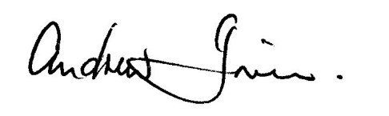
Andrew Irwin- Chairman Tangmere Parish Council
19 March 2023

All local groups and organisations are invited to take a table in the Small Hall to publicise their operations and there will be refreshments served in the Community Hall following the Meeting.

