Countryside Update
Tangmere Strategic Development Location (SDL)
June 2023 – Update regarding the Outline planning application
As you may be aware, Chichester District Council’s Planning Committee resolved to grant the Outline planning application for the Tangmere Strategic Development Location (SDL) in 2021, which will bring forward up to 1,300 new homes, 30% being affordable, as well as a primary school and exciting new community and commercial facilities at Tangmere.
The Tangmere SDL site boundary is denoted by a ‘red line’. There has been a minor amendment to the red line boundary in response to resident feedback which would remove 0.34ha of land to the west of Saxon Meadows from the site boundary; the revised red line boundary is shown below in the updated illustrative masterplan. This is a purely technical change that would retain an existing meadow, and it will not change the scheme beyond part of the proposed orchard being located elsewhere within the site.
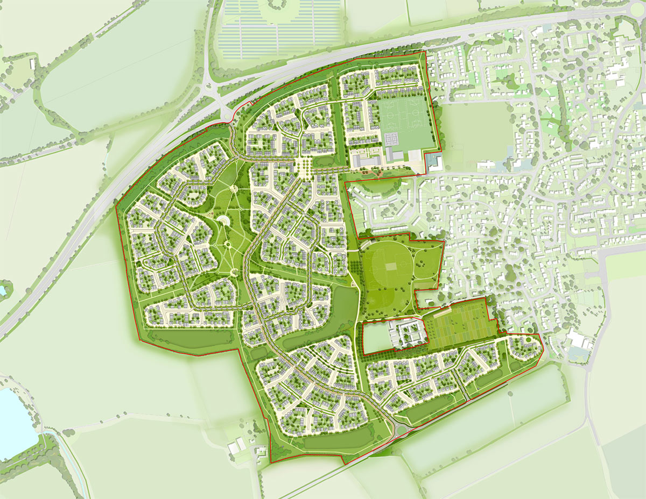
Countryside (now part of the Vistry Group) will continue to keep the community up to date and, if you have any questions, you can contact the team via countryside-tangmere@turley.co.uk, 0808 168 8296, or register for project updates on the website at www.countryside-tangmere.co.uk.

