LOCAL GOVERNMENT ACT 1972

PARISH OF TANGMERE

ANNUAL MEETING OF ELECTORS

NOTICE IS HEREBY GIVEN THAT-
The Annual Meeting of Electors for the Parish of Tangmere
will be held at
Tangmere Village Centre, Malcolm Road Tangmere PO20 2HS
On Tuesday 21 March 2023 at 7pm.

Local Government electors for the Parish will be entitled to speak and vote at the meeting which will be open to the public.

The business to be transacted at the meeting will be as follows:-

- Minutes of the Annual Meeting of Electors held on 28 April 2022

- Council Chairman’s Annual Report

- District/County Councillor’s Annual Report

- Reports from Local Groups, Clubs, Societies and other Voluntary and Statutory Organisations

- Other matters raised by Electors of the Parish

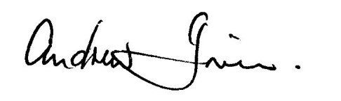
Andrew Irwin- Chairman Tangmere Parish Council
8th March 2023

